Daniel Onyeji
Multi-Node Kubernetes Deployment on Azure

Executive Summary
This submission demonstrates the design, deployment, and validation of a multi-node Kubernetes cluster on Microsoft Azure using kubeadm and Ansible. The solution includes cluster bootstrap, Calico CNI configuration, Azure networking integration, NodePort exposure, and resilience testing under simulated failure scenarios. The cluster was validated through multi-node scheduling, external connectivity tests, and node-drain failover simulations. Architectural tradeoffs and production-grade recommendations are clearly acknowledged.

1. Objective
Design, deploy, and validate a multi-node Kubernetes cluster on Microsoft Azure, expose a sample workload externally, and demonstrate:
• Multi-node scheduling
• Inter-node networking
• External service exposure
• Operational resilience under failure scenarios

2. Architecture Overview
Platform: Microsoft Azure
Region: North Europe
OS: Ubuntu 24.04 LTS
Container Runtime: containerd
CNI: Calico
Provisioning & Execution: Ansible + kubeadm
Cluster Topology:
gtvm1 – Control Plane – 172.16.0.4 – 4.231.249.122
gtvm3 – Worker – 172.16.0.5 – 40.67.232.178
Both nodes were deployed into the same Azure Virtual Network and subnet to ensure L3 connectivity.

3. Cluster Bootstrap
kubeadm init --pod-network-cidr=192.168.0.0/16
Kubeconfig was configured for cluster administration and Calico CNI installed to enable pod networking.
Worker node joined using kubeadm join token.

4. Cluster Validation
kubectl get nodes
Result:
gtvm1 Ready control-plane
gtvm3 Ready
kubectl get pods -o wide confirmed scheduling across both nodes.
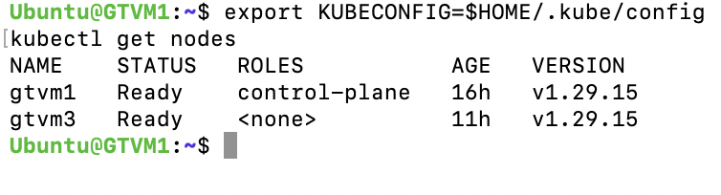

5. Service Exposure (NodePort)
Service Type: NodePort
NodePort: 30080/TCP
Azure NSG inbound rule added to allow TCP 30080 from public IP.

6. External Connectivity Validation
curl http://4.231.249.122:30080 → hello-from-gtvm1
curl http://40.67.232.178:30080 → hello-from-gtvm3
Validated Azure routing, NSG configuration, kube-proxy and cross-node service routing.

7. Resilience & High Availability Testing
kubectl delete pod -l app=echo → Pods recreated automatically.
kubectl drain gtvm3 --ignore-daemonsets --delete-emptydir-data
Workloads rescheduled to gtvm1 and service remained accessible.
kubectl uncordon gtvm3 → Pods redistributed.
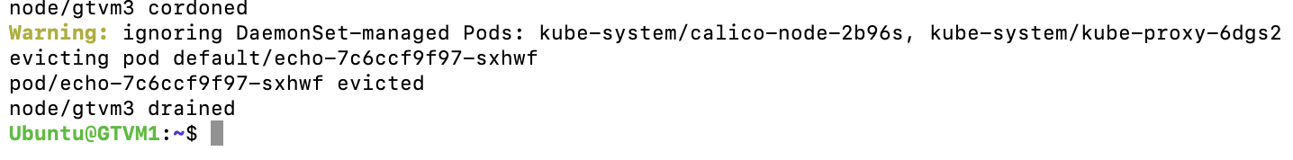

8. Troubleshooting & Cloud Considerations
• Incorrect subnet deployment corrected.
• Inter-node API connectivity validated via TCP tests.
• NSG rules configured for NodePort exposure.
• Azure CPU allocation constraint handled via --ignore-preflight-errors=NumCPU.

9. Architectural Limitations & Production Considerations
Single control-plane introduces a single point of failure. Production setup would use ≥3 control-plane nodes, quorum-based etcd, and internal load balancing across availability zones.
Control-plane VM was constrained to 1 vCPU. For production, ≥2 vCPU (preferably 4 vCPU) would be provisioned with appropriate capacity planning.

10. Conclusion
The cluster operates correctly under normal and simulated failure conditions.
The solution demonstrates Kubernetes bootstrap, networking integration, service exposure, operational troubleshooting, and resilience validation while clearly acknowledging production-grade improvements.

